Emanon College Lab Build
Emanon College needs to double the number of computer labs and computers in the college, and update all of the lab equipment to current technology. The objective of this project is to build ten computer labs at Emanon before Fall classes start.

Project Scope

Deliverables

Deliverable 1: Project Documentation
Project administration documentation, including plans, reports, quality documents, & closing documents.

Deliverable 2: Lab Design Documents
The design documents are comprehensive room drawings and specifications for all computer labs.

Deliverable 3: Ten Computer Labs
The primary deliverable of this project is ten new computer labs.

Deliverable 4: Lab Maintenance Documents
The lab maintenance documents are complete as-built documents and preventative and corrective maintenance procedures for all computer labs.

Approach
The project will be conducted in three major phases:
- Design – the overall lab requirements will be analysed and the labs will be designed.
- Construction – the labs will be built.
- Commissioning – the labs will be tested and operations and maintenance procedures will be established.

Project Schedule
The project was approved on January 5, 2009 and is planned to take eight (8) months to complete on August 28, 2009.

Project Budget
The total budget for this project is $1,665,000. This includes a 10% contingency reserve amount and only reflects the direct costs associated with this project. This budget specifically does not include the overhead costs associated with labour or materials.

Task Expense Summary
The following is a breakdown of the estimated costs on this project by phase including labour and material costs and contingency reserves:

 | 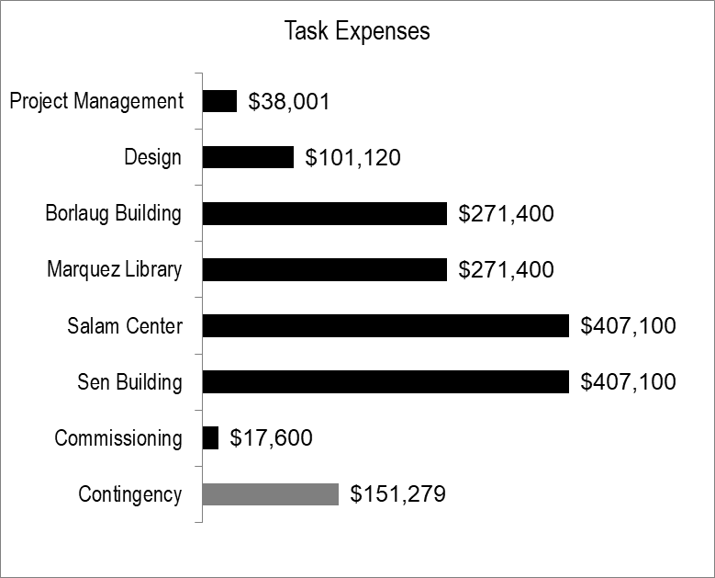
  Summary Tasks | Costs
  Project Management | $38,001
  Design | $101,120
  Construction
  Borlaug Building | $271,400
  Marquez Library | $271,400
  Salam Center | $407,100
  Sen Building | $407,100
  Commissioning | $17,600
  Sub-total | $1,513,721
  Contingency | $151,279
  Total | $1,665,000

Resource Expense Summary
The following table and chart represent the project baseline by resource type:

 | 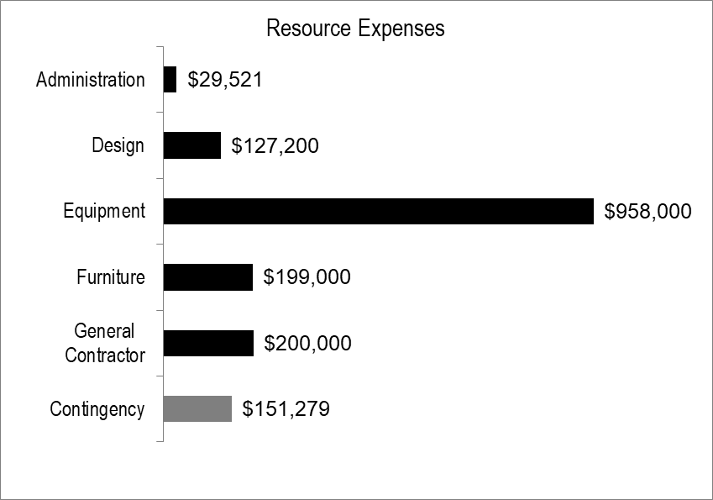
  Resource Group | Costs
  Administration | $29,521
  Design | $127,200
  Equipment | $958,000
  Furniture | $199,000
  General Contractor | $200,000
  Sub-total | $1,513,721
  Contingency | $151,279
  Total | $1,665,000

Project Risk Management
The following table represents only the highest exposure risks on this project:

Risk Event | Exposure | Response Strategy | Responsibility
Project funding is reduced by more than 25% during project planning. | $75,000 | Establish full project funding approval as early as possible, with commitment to contracts as top priority. | Sponsor

Communications Management
The following table outlines the reports to be generated and distributed throughout this project:
Report Type | Timing | Recipients | Responsible
Periodic Task Progress Reports | Bi-weekly | Project Manager | Team, Sub-contractors
Project Performance Reports | Monthly | Management | Project Manager
Upcoming Activity Memo | Weekly | Team, Sub-contractors | Project Manager
Project Closeout Report | On Close | Management | Project Manager
Lessons Learned Report | On Close | All Stakeholders | Project Manager, Team

Project Plan Approval
The following signature indicates acceptance of the information, terms and conditions, and specifications presented in this document. This document is supplemental to the contract and will be considered part of the agreement between the parties. Any amendments to the services provided under this project plan must be documented and accepted by both parties using change control.
Kazaki Mikami |  | 13 March 2009
Kazaki Mikami |  | Date
President, Emanon College

